Student Getting Started Guide

Welcome to The HIVE
The HIVE provides you with a central location to connect to the people and services that can help you finish what you start – all accessible from the side navigation menu of your home page in The HIVE .
Log in to your The HIVE Home page by going to https://csbsju.The HIVEsolutions.com/The HIVE-ops/
The navigation menu includes access to a customizable profile and personalized channels that make it easy to schedule the dedicated time you need with your instructors, advisors, or other campus services and staff members. The HIVE can also help you manage the steps you need to take to stay on track and meet your goals.
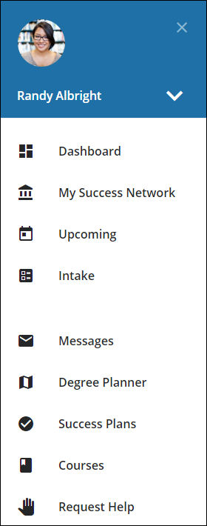
Here are three great ways to get started:
- Set up your profile
Review you profile for accuracy.
- Connect to people and services that can help you
Use your personalized My Success Network and Courses channels for quick access to contact information, appointment scheduling, and course help.
- Stay on track
Use the Upcoming tab to keep track of upcoming appointments, and your personalized Dashboard to see assignments, plans, and recommendations from your instructors.

Not sure what you need?
Browse the Services Catalog or use the Request Help option if you can’t find what you’re looking for through your personalized channels.

  - That’s it. Simple for you. Powerful for your future.

Set up your Profile
Begin by reviewing your student profile. Most fields will already be completed, and many cannot be changed. Your photo will be brought over from the student ID system. Your profile lets instructors and advisors know who you are and how to contact you.
- Open the navigation menu and click your name, and then Edit Profile to open your profile.
From here, review your contact information. You have the option to add a secondary email address for receiving emails. Please keep in mind, messages will already go to your campus email when sent from the HIVE. Only add a secondary email if you wish to be contact by both by campus email and a secondary email.
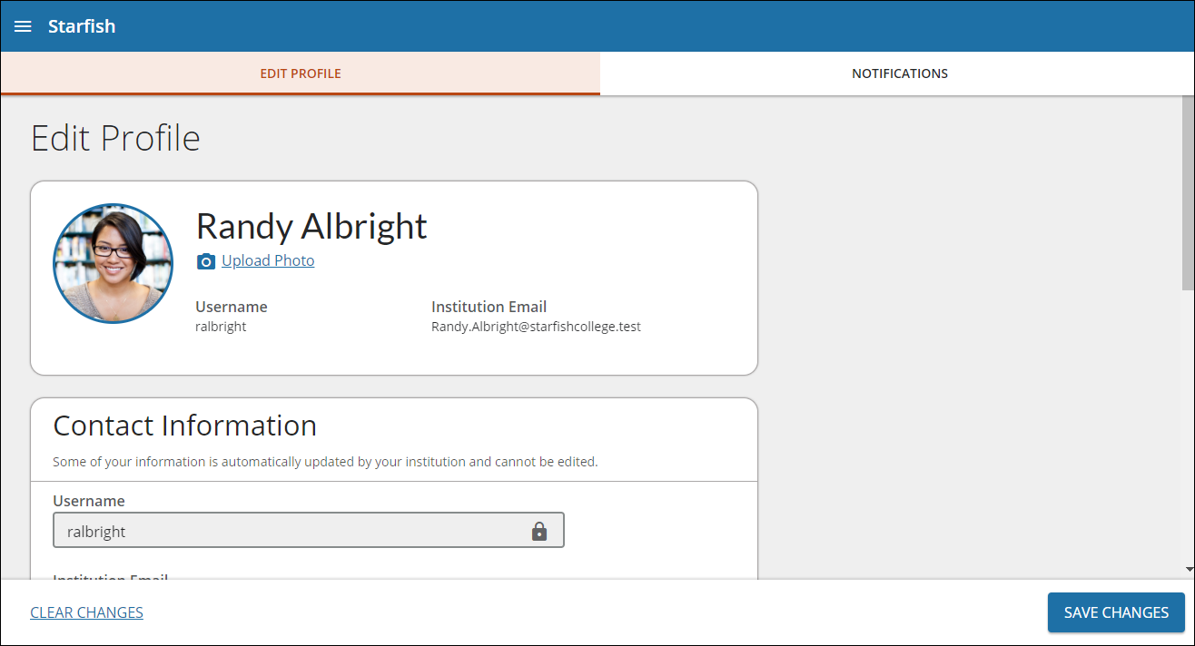
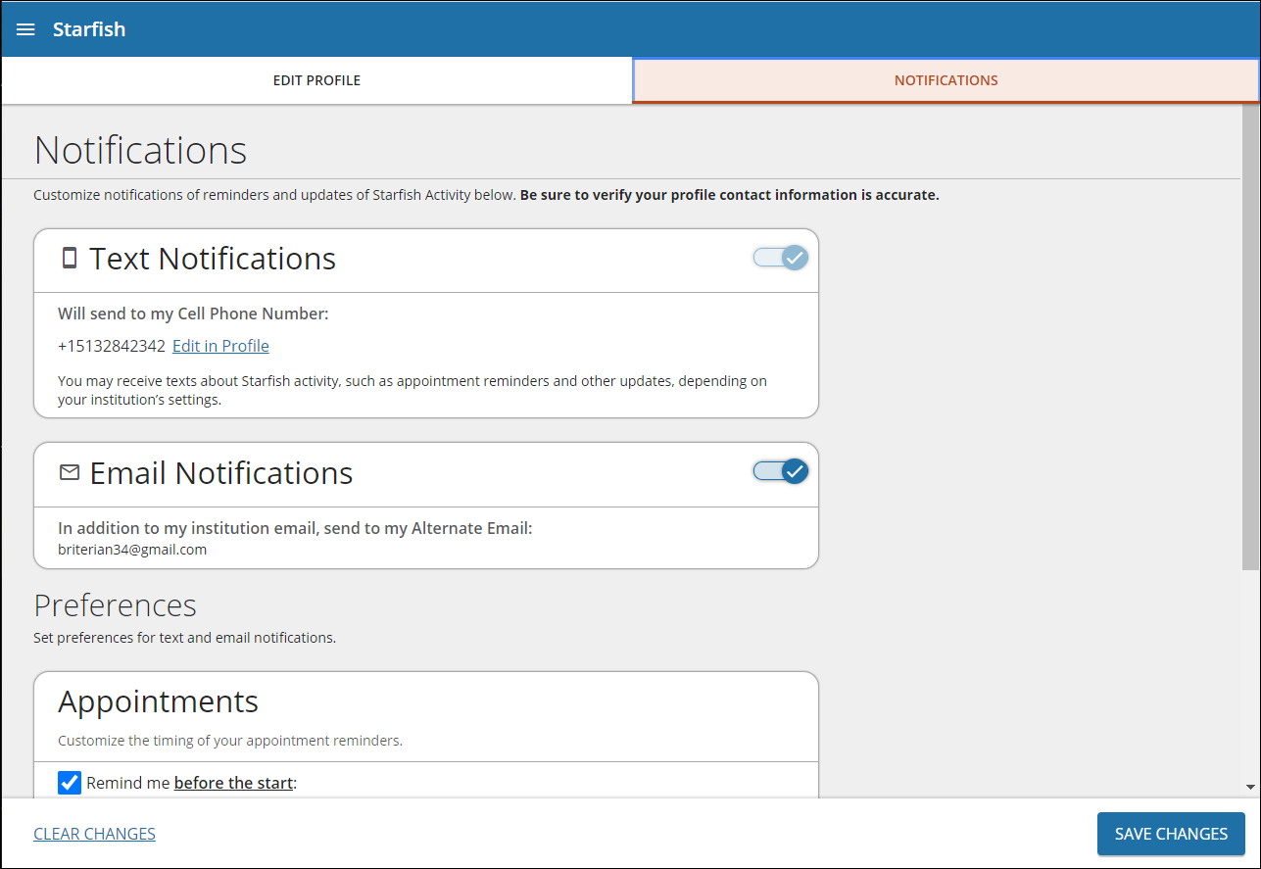
- Once you have made your desired changes to your profile, click the Save Changes button to save your updates.

Notifications
CSB and SJU have turned on text notifications, you can opt in/out via the Notifications tab. We encourage you to leave texting turned on as its use will be limited, and texting will only be used for select important, notifications. You can also manage email notifications and appointment preferences here as well.

Connect to people and services that can help you
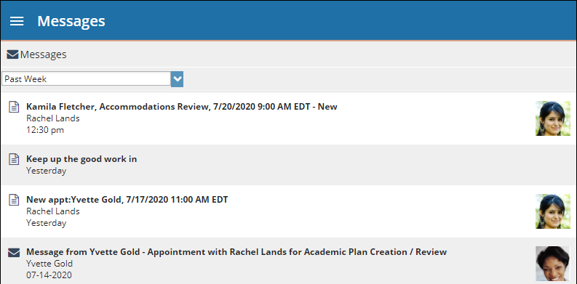
The My Success Network and Courses channels display you instructors, coaches, advisors and other staff connected to you on campus. Here you can find key contact information as well as links to student service web sites and online appointment scheduling.

Messages
Select Messages to display messages sent to you in The HIVE. Click on any message in the list to display its full contents.

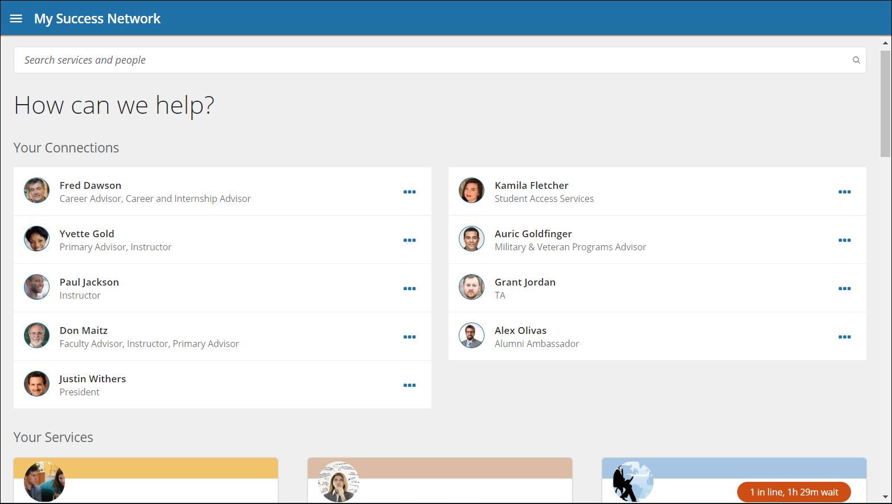
My Success Network
Select My Success Network from the navigation menu to display your personalized network. This channel lists the people and resources that are available to assist you. For each person or service listed, you will find contact information, supporting websites, and, if online scheduling is enabled, a link to Schedule Appointment. If a service includes a waiting room for walk-in appointments, you can click the “Waiting Room” link to find out how many students are currently in line.
The Services that are personalized to you are displayed first. Select Show Other Services at the bottom of the page to see additional services.

Courses
Select Courses from the side navigation menu to display information about courses you are enrolled in as well as contacts and available support related to each. Like the My Success Network channel, it is personalized to show the people and services specific to the courses you are taking, and gives you the ability to Schedule Appointment or Request Help related to a course.
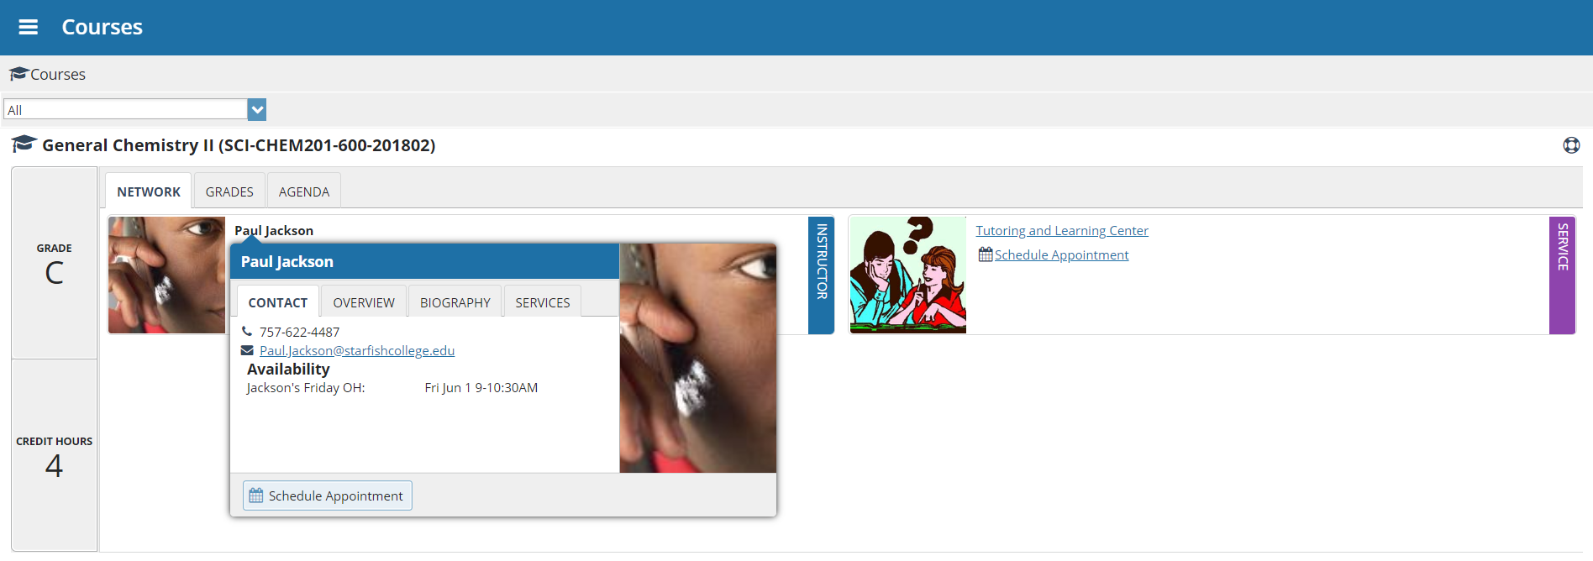
- Click the Help icon () link in the upper, right corner next to any of the courses in which you are currently enrolled.
- This will bring up the Request Help form. Select the Type of help needed from the drop down menu and give specific Details on how staff can assist you.
- Click the Submit button to submit your request when you are finished.

Make an Appointment
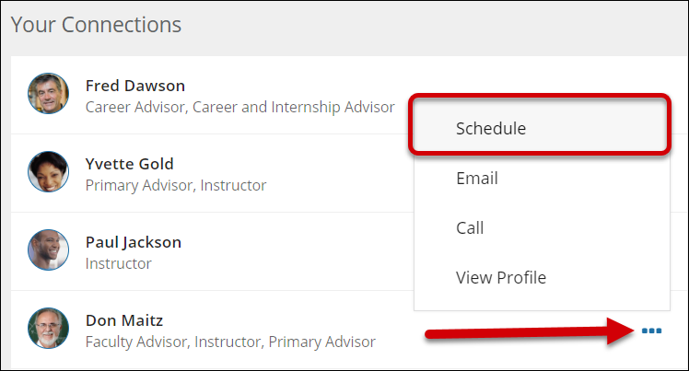
- From the My Success Network, click the ellipsis beside the name of the person you want to schedule an appointment with, and then select Schedule.
For Services where appointments are available, select Schedule for the desired service.
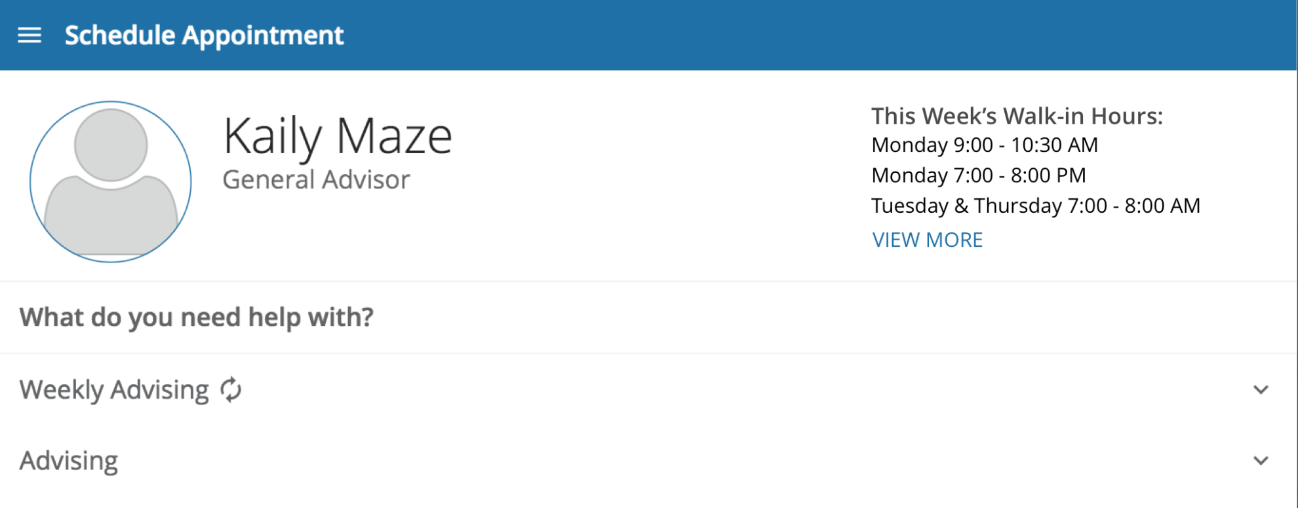
Or, from the Courses channel, select Schedule Appointment below the contact information for the desired person or service.
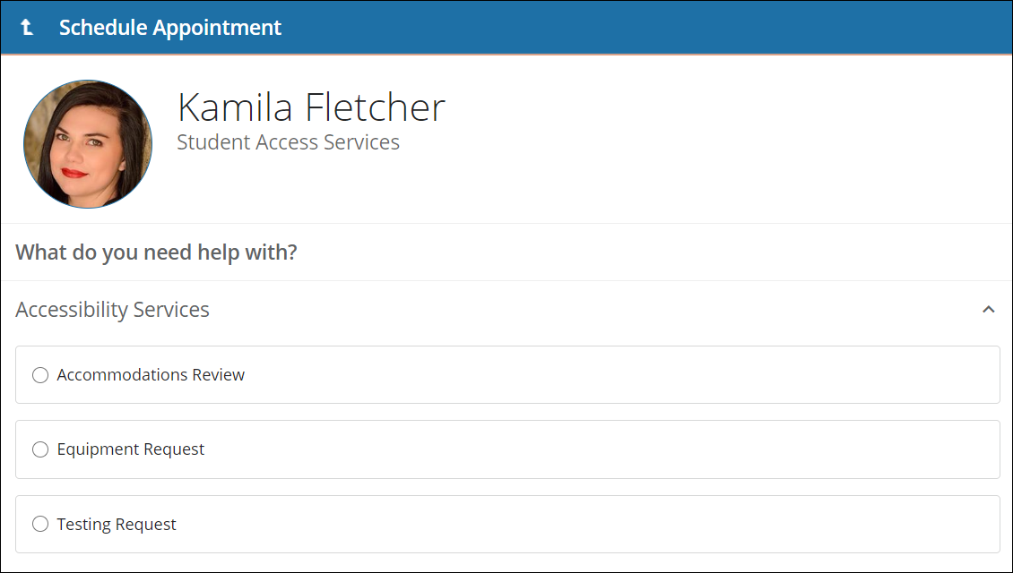
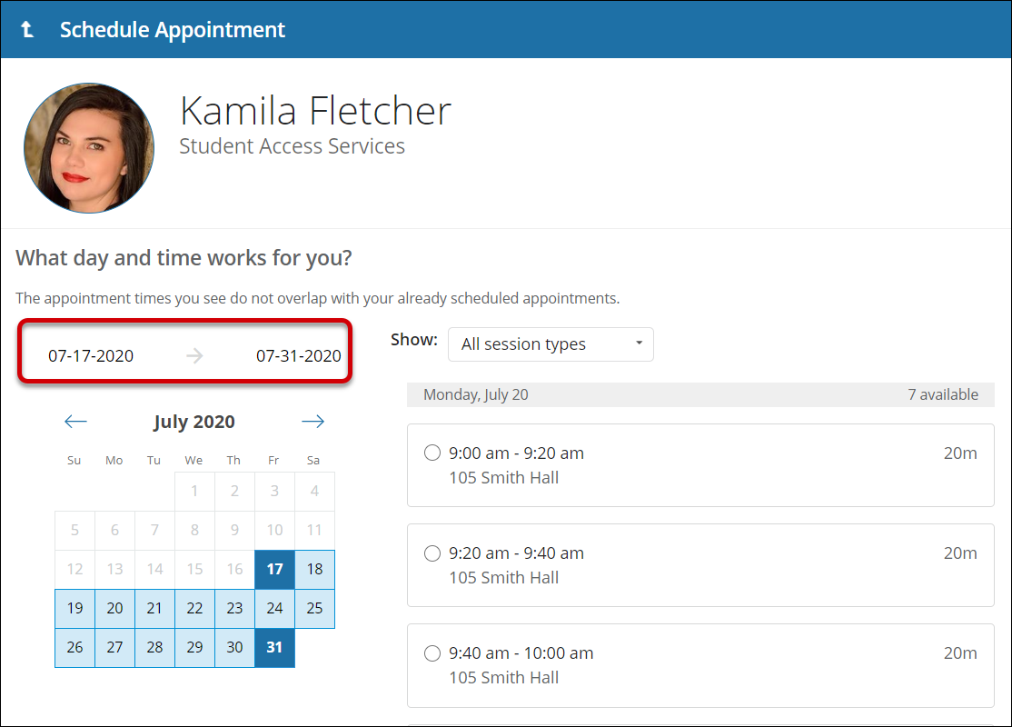
- Select the type of appointment you want to schedule and choose a reason from the list.
- Adjust the date range as needed to find days and times that work for your schedule, and then select a time from the list. Be sure to note location of the meeting, depending on the faculty/staff or service there may be appointments offered both at CSB and SJU.
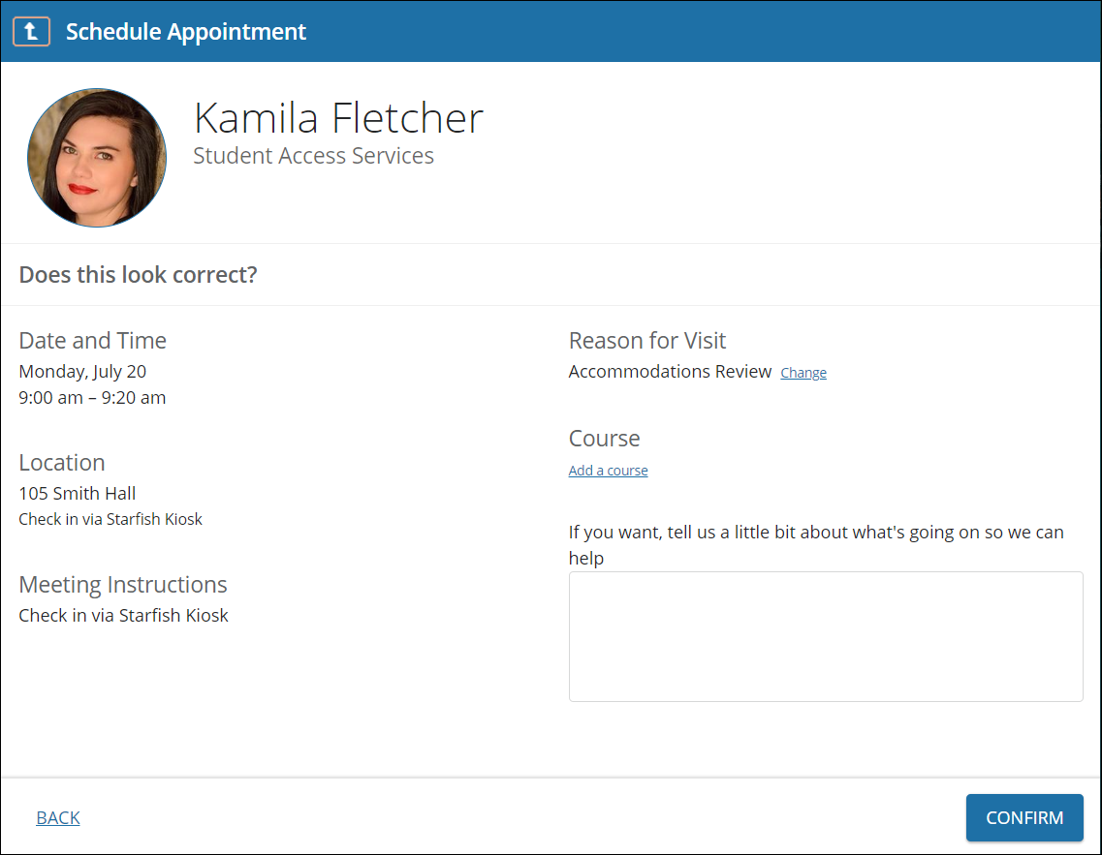
- Complete your sign up by adjusting any details, such as duration or course, where applicable, and add a description for why you want to meet.
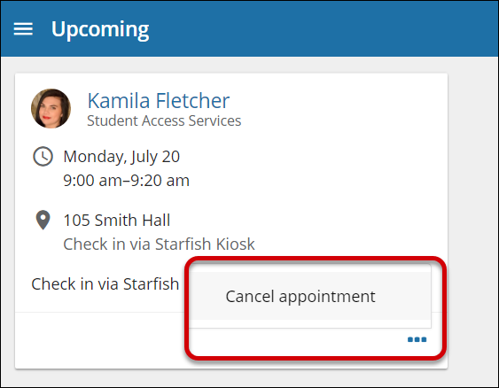
- Click Confirm to finish scheduling the appointment. A confirmation page displays allowing you to make changes to the appointment or jump to another page. Additionally, you will get an email with the appointment details and the appointment will be listed on the Upcoming tab.

Change an Appointment
On the Upcoming tab, you can view scheduled appointments and make changes. Click on an appointment to make changes to it, such as changing the location or duration, when available. You can cancel the appointment by clicking the ellipsis and selecting Cancel appointment.

Success Plans
The Success Plans channel will display any customized success plans created for you. These plans contain specific tasks with due dates. Click the View Details button associated with a plan to display a printable version of the plan.

Request Help
Select Request Help from the navigation menu to see information about where to go for assistance.
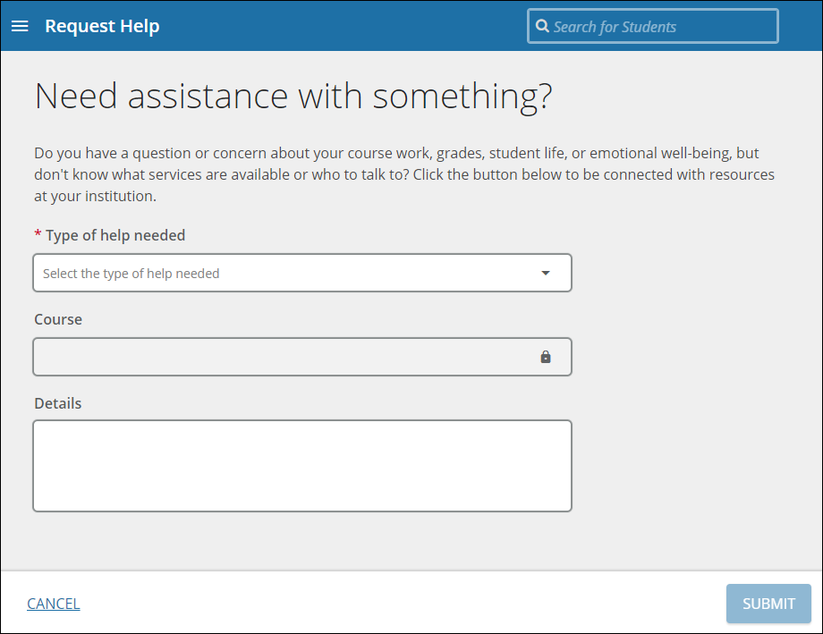
From here, you can select Help Me to submit a request for help. You will be asked to provide additional information such as the type of help you are requesting, the related course (if applicable), and a description.
We encourage you to make your description as detailed as possible to insure you get the appropriate help needed. Click Submit to submit your request when done.

Dashboard
Your Dashboard also displays upcoming appointments* as well as date-based tasks on the left to help you plan your week. The right-hand column of your Dashboard highlights items that require your attention and may include alerts related to your class work, recommended referrals to campus support offices to help you succeed, and Kudos from your instructors. Click on your course in the calendar to open a pop out box with your instructor’s name and link to connect with them or services connected to your courses (think Math Center, Chemistry Assistance or Academic Advising).
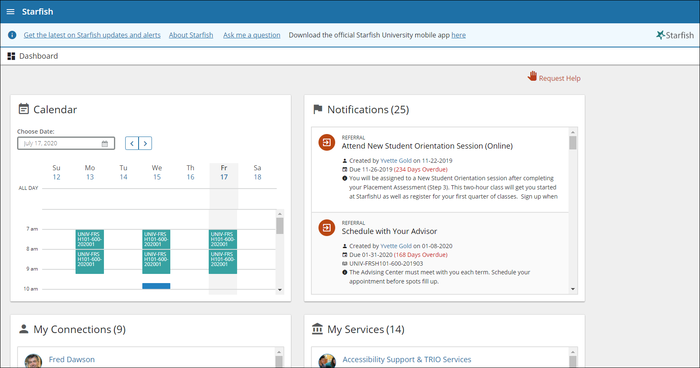
*Students with a Peer Leaders Role who hold appointments with other students (i.e. Career Ambassadors, Writing Center Peer Tutors, etc) will NOT see appointments for their tutoring/service appointments listed in this view – go to your Appointments Channel to see these appointments.

